Business Requirement Document

# 1. Introduction

[](https://mrservice9.com/AGILE_Master_Collection/bba8c060-73b5-4cb1-9c56-583475e6ef6d/_apis/wit/attachments/aae18caf-e522-4e1d-bb8f-6eea7aef6e66?fileName=MRLogo.png)

A **Business Requirements Document** (BRD) is a formal contract between the organization and the customer for a product. By describing in full detail all the processes that should be implemented, a BRD is used through the entire cycle of the project to ensure that the product meets the detailed specifications and that the project gains value and achieves the desired results. If it is prepared for a technical product, the BRD also includes technical specifications.

# 2. Overview

Key Elements of a Business Requirements Document

The author of a Business Requirements Document - a business analyst or a project manager - should have a thorough understanding of the business processes and the key objectives of the project to ensure proper implementation of different requirements and different elements within the requirements.

The most important element of a BRD is the scope of the project, which includes any restrictions and constraints that need to be considered during the development process. The scope is a functional requirement that basically answers three questions:

* What is the problem that the organization needs to solve?
* What are the restrictions that need to be considered?
* Is the time and money invested in solving the problem worthwhile?

# 3. In scope

A challenge we encounter quite often when first working with new clients is defining, at a fairly granular level, a project’s scope. Often organisations know what they want in terms of high-level project deliverable, but have not gotten down to the nitty-gritty stuff – but that’s what we’re here for!

Project scope is the part of project planning that involves determining and documenting a list of specific project goals, deliverable, features, functions, tasks, deadlines, and ultimately costs. In other words, it is what needs to be achieved and the work that must be done to deliver a project.

It is important to pin down the scope early in a project’s life cycle as it can greatly impact the schedule or cost (or both) of the project down the track.

[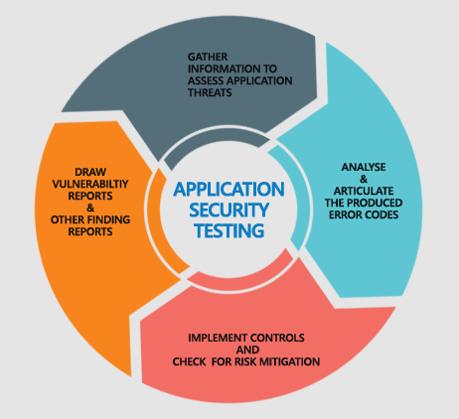](https://mrservice9.com/AGILE_Master_Collection/bba8c060-73b5-4cb1-9c56-583475e6ef6d/_apis/wit/attachments/21916c9e-bd92-4bdc-a007-1e473a57b500?fileName=application-security-testing-inner.png)

# 4. Security

Application security describes security measures at the application level that aim to prevent data or code within the app from being stolen or hijacked. It encompasses the security considerations that happen during application development and design, but it also involves systems and approaches to protect apps after they get deployed.

Application security may include hardware, software, and procedures that identify or minimize security vulnerabilities. A router that prevents anyone from viewing a computer’s IP address from the Internet is a form of hardware application security. But security measures at the application level are also typically built into the software, such as an application firewall that strictly defines what activities are allowed and prohibited. Procedures can entail things like an application security routine that includes protocols such as regular testing.

[](https://mrservice9.com/AGILE_Master_Collection/bba8c060-73b5-4cb1-9c56-583475e6ef6d/_apis/wit/attachments/0e0158ae-14c5-412e-8f94-01629b638ba2?fileName=download.jfif)

## 4.1 User management

User management is a core part to any directory service and is a basic security essential for any organization. User management enables admins to control user access and on-board and off-board users to and from IT resources.

[](https://mrservice9.com/AGILE_Master_Collection/bba8c060-73b5-4cb1-9c56-583475e6ef6d/_apis/wit/attachments/2b82eef4-3f59-4ca7-9675-4c6d89719dea?fileName=function-of-identity-as-a-service.jpg)

### 4.1.1 Add User

Add a new user account

Open the Activities overview and start typing Users.

Click on Users to open the panel.

Press Unlock in the top right corner and type in your password when prompted.

Press the + button, below the list of accounts on the left, to add a new user account.

### 4.1.2 Edit User

How can I edit a user?

Go to Settings > Customize > Manage Users > Users.

To edit the information associated with a user, click on the 'Edit' option found there.

### 4.1.3 Delete User

Log in to your server via SSH.

Switch to the root user: sudo su -

Use the userdel command to remove the old user: userdel user's username.

Optional: You can also delete that user's home directory and mail spool by using the -r flag with the command: userdel -r user's username.

### 4.1.4 Copy User

Double-click System. Click the Advanced tab, and then, under "User Profiles", click Settings. Click the profile you want to copy, and then click Copy to. In the Copy To dialog box, click Browse to select the directory to which you want to copy the

### 4.1.5 Disable User

To disable a user's account:

Go to Administration > Employees and Organization > Users.

Find the user whose account you want to disable. ...

Click the name of the user.

Click the Licenses item in the menu on the left-hand side of the screen.

From the Login Status field, select Disabled.

### 4.1.6 Set user rights

See Required Run As user permissions.

Right-click the folder and click Properties.

Click the Security tab and click Edit.

In Group or user names, click the name of the user you want to grant permissions to, or click Add to add a user that does not appear in the list.

# 5. test